Synchrotron Soleil Bensikin Manuel
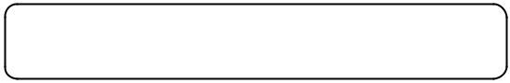


Reference: INF-XXX
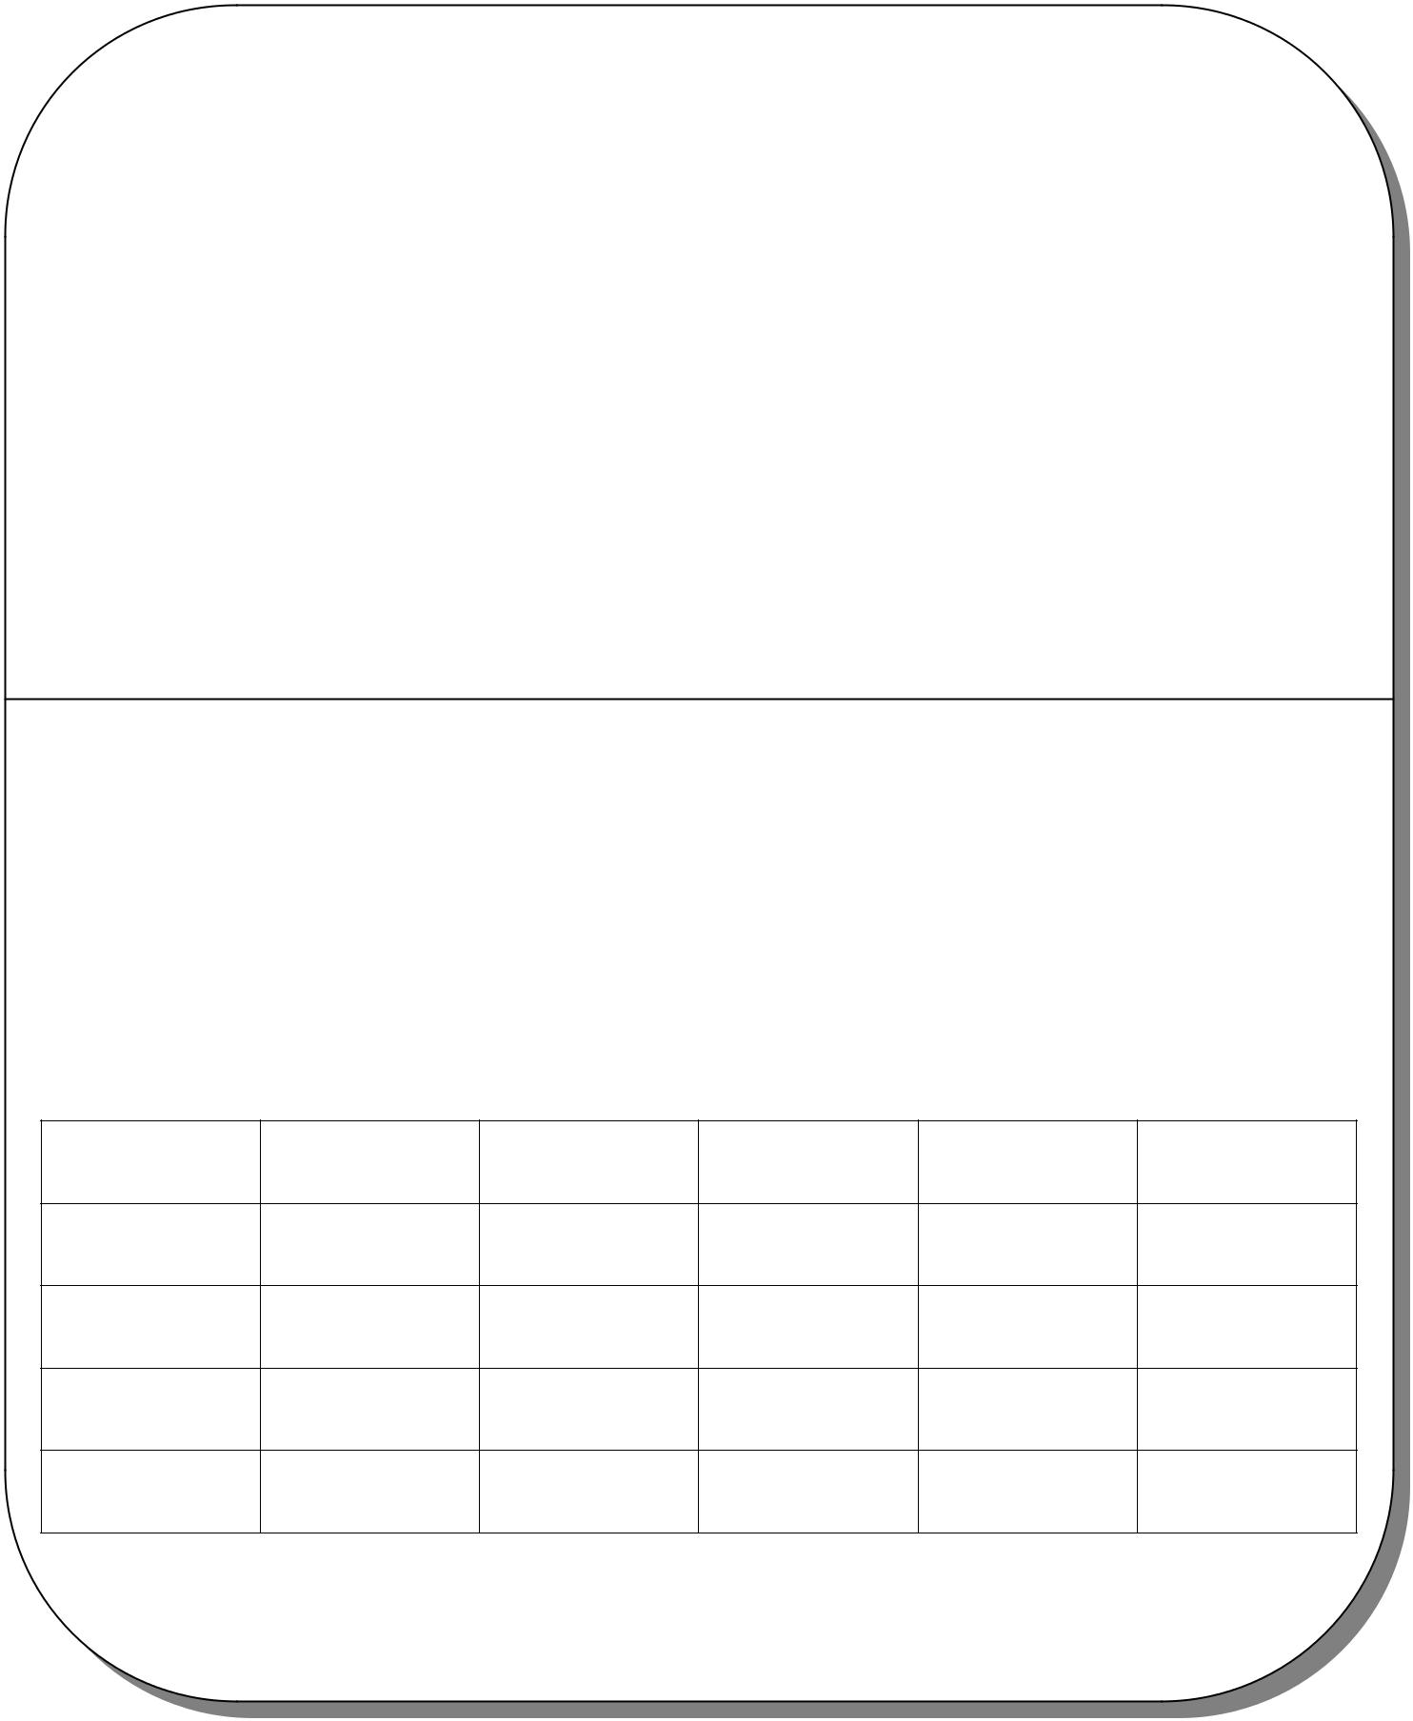

Bensikin Manual

for Bensikin v1.0

Diffusion :

Diffusion List

Date |  | Writer | Auditor | Validation |  | Modifications |  | Indication
2005/11/17 R.Girardot

“Reference” Last Update : 8 February 2007 Page 1/26
Synchrotron Soleil Bensikin Manual

Index

1. | INTRODUCTION.................................................................................................................................................................... |  |  | 4
2. | APPLICATION’S CONTEXT: CONTEXTS AND SNAPSHOTS. .................................................................................... |  |  | 4
3. | APPLICATION’S DESCRIPTION AND GOALS ............................................................................................................... |  |  | 4
 | 3.1. | APPLICATION’S GOALS ....................................................................................................................................................... |  | 4
 | 3.2. | A FIRST LOOK TO BENSIKIN................................................................................................................................................ |  | 4
4. | PROFILE MANAGER............................................................................................................................................................ |  |  | 6
 | 4.1. | CREATING A NEW PROFILE ................................................................................................................................................. |  | 6
 | 4.2. | DELETING AN EXISTING PROFILE ........................................................................................................................................ |  | 6
 | 4.3. | LAUNCHING APPLICATION WITH AN EXISTING PROFILE ...................................................................................................... |  | 7
 | 4.4. | SESSIONS............................................................................................................................................................................ |  | 7
5. | CONTEXT MANAGEMENT................................................................................................................................................. |  |  | 8
 | 5.1. | CREATING A NEW CONTEXT ............................................................................................................................................... |  | 9
 | 5.1.1. |  | Classic way (tree) ................................................................................................................................................... | 10
 | 5.1.2. |  | Alternate way (table) .............................................................................................................................................. | 11
 | 5.2. | MODIFYING AN EXISTING CONTEXT ................................................................................................................................. |  | 13
 | 5.3. | LOADING A CONTEXT ....................................................................................................................................................... |  | 14
 | 5.3.1. |  | Loading a context from database............................................................................................................................ | 14
 | 5.3.2. |  | Loading a context from file..................................................................................................................................... | 14
 | 5.4. | PRINTING A CONTEXT....................................................................................................................................................... |  | 15
 | 5.5. | SAVING A CONTEXT.......................................................................................................................................................... |  | 15
6. | SNAPSHOT MANAGEMENT ............................................................................................................................................. |  |  | 16
 | 6.1. | CREATING A NEW SNAPSHOT ............................................................................................................................................ |  | 17
 | 6.2. | LOADING A SNAPSHOT...................................................................................................................................................... |  | 17
 | 6.2.1. |  | Loading a snapshot from database......................................................................................................................... | 17
 | 6.2.2. |  | Loading a snapshot from file .................................................................................................................................. | 17
 | 6.3. | EDITING A SNAPSHOT ....................................................................................................................................................... |  | 18
 | 6.3.1. |  | Setting equipments with a snapshot ........................................................................................................................ | 18
 | 6.3.2. |  | Snapshot comparison.............................................................................................................................................. | 19
 | 6.3.3. |  | Snapshot Details copy............................................................................................................................................. | 19
 | 6.3.4. |  | Modifying a snapshot comment .............................................................................................................................. | 19
 | 6.4. | PRINTING A SNAPSHOT ..................................................................................................................................................... |  | 20
 | 6.5. | SAVING A SNAPSHOT ........................................................................................................................................................ |  | 20
7. | FAVORITES .......................................................................................................................................................................... |  |  | 21
 | 7.1. | ADDING A CONTEXT TO FAVORITES.................................................................................................................................. |  | 21
 | 7.2. | SWITCHING TO A CONTEXT IN FAVORITES ........................................................................................................................ |  | 21
8. | OPTIONS................................................................................................................................................................................ |  |  | 22
 | 8.1. | LOGS OPTIONS ................................................................................................................................................................. |  | 22
 | 8.2. | APPLICATION’S HISTORY SAVE/LOAD OPTIONS ................................................................................................................ |  | 23
 | 8.3. | SNAPSHOT OPTIONS ......................................................................................................................................................... |  | 24
 | 8.4. | CONTEXT OPTIONS........................................................................................................................................................... |  | 26
9. | THE BENSIKIN TOOLBAR................................................................................................................................................ |  |  | 26

“Reference” Last Update : 8 February 2007 Page 2/26
Synchrotron Soleil Bensikin Manuel

Figure Index

Figure 1: Bensikin Profile Manager 4

Figure 2: Bensikin Main Panel 5
Figure 3: Creating a new profile 6
Figure 4: Profile Selection 6
Figure 5: Multi sessions disabled 7
Figure 6: Multi sessions enabled 7
Figure 7: Context Control Panel 8
Figure 8: Application first start 9
Figure 9: Options - Context Tab 11
Figure 10: Bensikin with Context Table Selection Mode (new Context) 12
Figure 11: Bensikin with Context Table Selection Mode (modified Context) 13
Figure 12: Database Context Filter Dialog 14
Figure 13: Snapshot Control Panel 16
Figure 14: Modified snapshot 18
Figure 15: Snapshot Comparison - full table 19
Figure 16: Snapshot Edit Clipboard Dialog 19
Figure 17: Logs Options 23
Figure 18: Save Options 24
Figure 19: Snapshot Options 25
Figure 21: The Bensikin toolbar 26

“Reference” Last Update : 8 February 2007 Page 3/26
Synchrotron Soleil Bensikin Manual

1. Introduction

This document is an end-user guide to using the Bensikin application, and a brief developer-oriented presentation of the application’s architecture.

2. Application’s context: Contexts and Snapshots.

A snapshot is, as said in the name, a view of the equipments (attributes) at a precise instant. A snapshot is based on a context, that is a filter to only view a specific list of attributes. A context is described by meta-data (author, description, etc…), so that user can know which context is used what for.

A snapshot can also be used to reset equipments to the values of this snapshot.

3. Application’s description and goals

3.1. Application’s goals

Bensikin allows the user to define contexts and snapshots. Snapshots be saved as files and modified.

Bensikin v1.0 is ready for multi-user functioning, which has for consequence the need to define profiles. A profile is a way to map a user with a working directory. An important conséquence of this is, that 2 different user must not use the same working directory, or you may encounter crashes. A profile has a name and a path to a working directory.

Bensikin is thus naturally divided (both in functionalities and display) in three parts:

- The profile part, that is an introduction to the rest of the application

- The context part

- The snaphot part

3.2. A first look to Bensikin

Figure 1: Bensikin Profile Manager
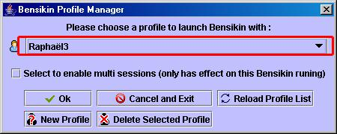

Profile Selection Combo Box

“Reference” Last Update : 8 February 2007 Page 4/26
Synchrotron Soleil Bensikin Manuel

Figure 2: Bensikin Main Panel
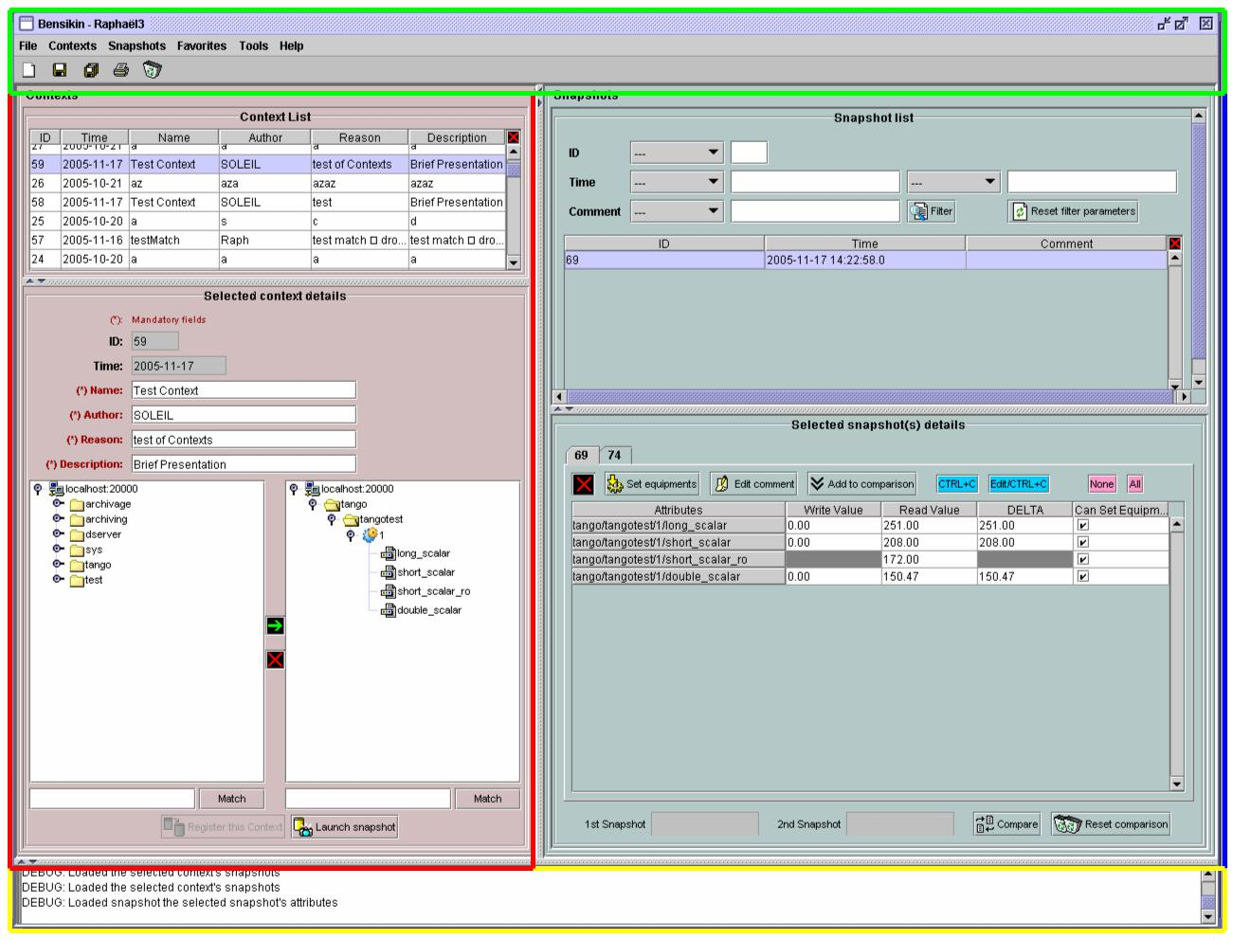

Menu and Tool bar

Context Control panel Snapshot Control panel

Application’s Logs panel

- The Bensikin Profile Manager is here to manage profiles which means :

o Creating a new profile

o Deleting an existing profile

o Launching application with a profile chosen in a list

- The Bensikin Profile Manager also allows you to quickly manage sessions

- The Context Control Panel is where user can manage contexts, which means creating, loading and modifying contexts, and launch snapshots based on the defined contexts.

- The Snapshot Control Panel is where user can manage snapshots, which means saving snapshots in files, loading snapshots from database and files, temporaly modify snapshots’ attributes values and set equipment with defined snapshots (whith or without modifying snapshots) or a subpart of them.

- The Logs panel displays success/failure messages to the user upon realization of an action.

- The Menu and the Tool bar are for actions shortcuts and application’s options.

“Reference” Last Update : 8 February 2007 Page 5/26
Synchrotron Soleil Bensikin Manuel

4. Profile Manager

The Figure 1: Bensikin Profile Manager presents the Profile Manager Interface, on application start. With this manager, you can create a new profile, or delete or use an existing one.

To quit the application, simply click on or button.

Existing profiles are listed in the Profile Selection Combo Box, which you can reload by clicking on

button (if you think that someone could have modified it by creating a new profile or deleting an existing one, for example).

4.1. Creating a new profile

To create a new profile, click on the button (At the bottom left of the panel). A new diaalog will appear, as following :

Figure 3: Creating a new profile
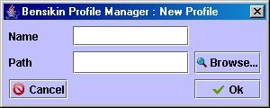

In this new dialog, you will have to enter the name of your new profile and the path of the application working

directory for this profile. If you prefer, you can browse for the path by clicking on the button. Then, a classic browsing dialog will be displayed, in which you can choose the directory. When both fields (“Name”

and “Path”) are fullfilled, click on button to validate your new profile and add it in the list of existing

profiles. If you click on or button, you go pack to the first dialog, as presented in Figure 1:

Bensikin Profile Manager, and nothing is done.

4.2. Deleting an existing profile

To delete an existing profile, first select the profile in the Profile Selection Combo Box, as following :

Figure 4: Profile Selection
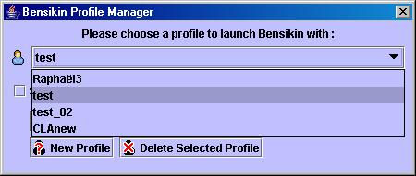

When the profile is selected, click on button to delete it. If you do so, you won’t be able to use this profile any more (and no other user either), because the profile is definitely removed from list.

The profile deletion doesn’t involve the corresponding Bensikin directories deletion.

“Reference” Last Update : 8 February 2007 Page 6/26
Synchrotron Soleil Bensikin Manuel

4.3. Launching application with an existing profile

To launch application with an existing profile, first select the profile in the Profile Selection Combo Box, as presented in Figure 4: Profile Selection.

Then, click on button, and you will reach the application main panel configured with this profile (the profile name is displayed in frame title, see Figure 2: Bensikin Main Panel)

4.4. Sessions

With the Bensikin Profile Manager, you have the possibility to enable or not multi sessions. To do so, you have to

select or unselect the check box: . It only affects the Bensikin you just started to run.

The expected behaviour is the following:

- If no other Bensikin is launched on the profile you selected, checking or unchecking the check box will not have any effect. Bensikin will just run with the selected profile and work in its directory.

- If another Bensikin is already running with the selected profile

- If the checkbox is unchecked, then a dialog will appear to warn you about the fact that another Bensikin is running. Closing this dialog will send you back to the profile manager.

Figure 5: Multi sessions disabled
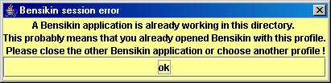

- If the checkbox is checked, then a dialog will appear to warn you about the fact that another Bensikin is running. Closing this dialog will continue run Bensikin. However, Bensikin will run in a sub directory of the profile working directory, and you will not be able to retrieve this session on Bensikin next start.

Figure 6: Multi sessions enabled
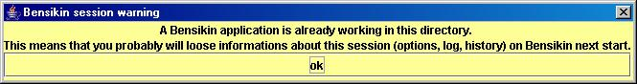

“Reference” Last Update : 8 February 2007 Page 7/26
Synchrotron Soleil Bensikin Manuel

5. Context Management

This section describes how to control contexts with Bensikin. A context is a list of attributes on which you can make a snapshot. A context has an ID and a creation date, both defined by the database. A context also has a name, an author, a reason and a description. The reason usually describes why the context was created (example: because of an incident or in order to set some equipments), whereas the description is here to have an idea of what kind of attributes you will find in this context.

Contexts are managed in the context control panel :

Figure 7: Context Control Panel
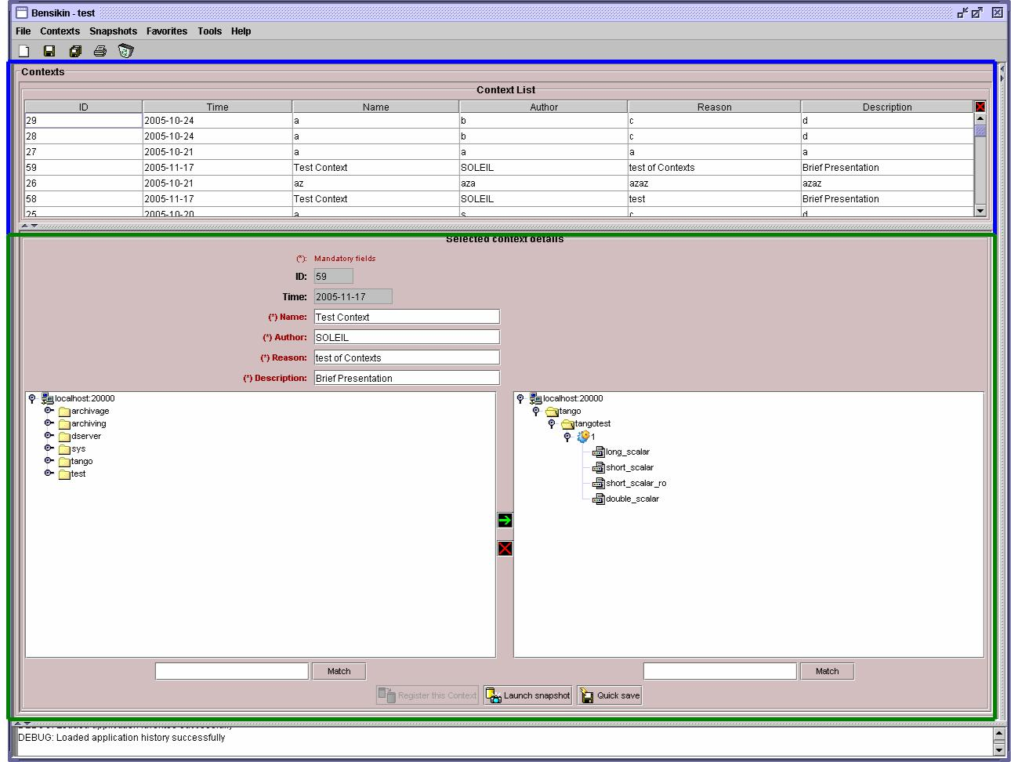

Context List sub panel

Context Details sub panel

“Reference” Last Update : 8 February 2007 Page 8/26
Synchrotron Soleil Bensikin Manuel

5.1. Creating a new context

To create a new context, click on the “new” icon in toolbar ( ), or choose he option to make a new context from “File” menu or “Contexts” menu :
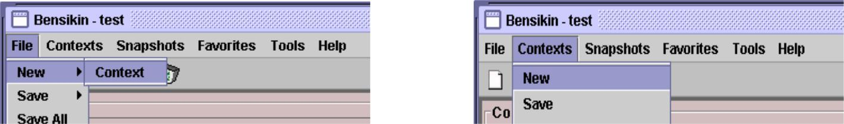

You also are ready to make a new context at application first start or by clicking on the “reset” icon () :

Figure 8: Application first start
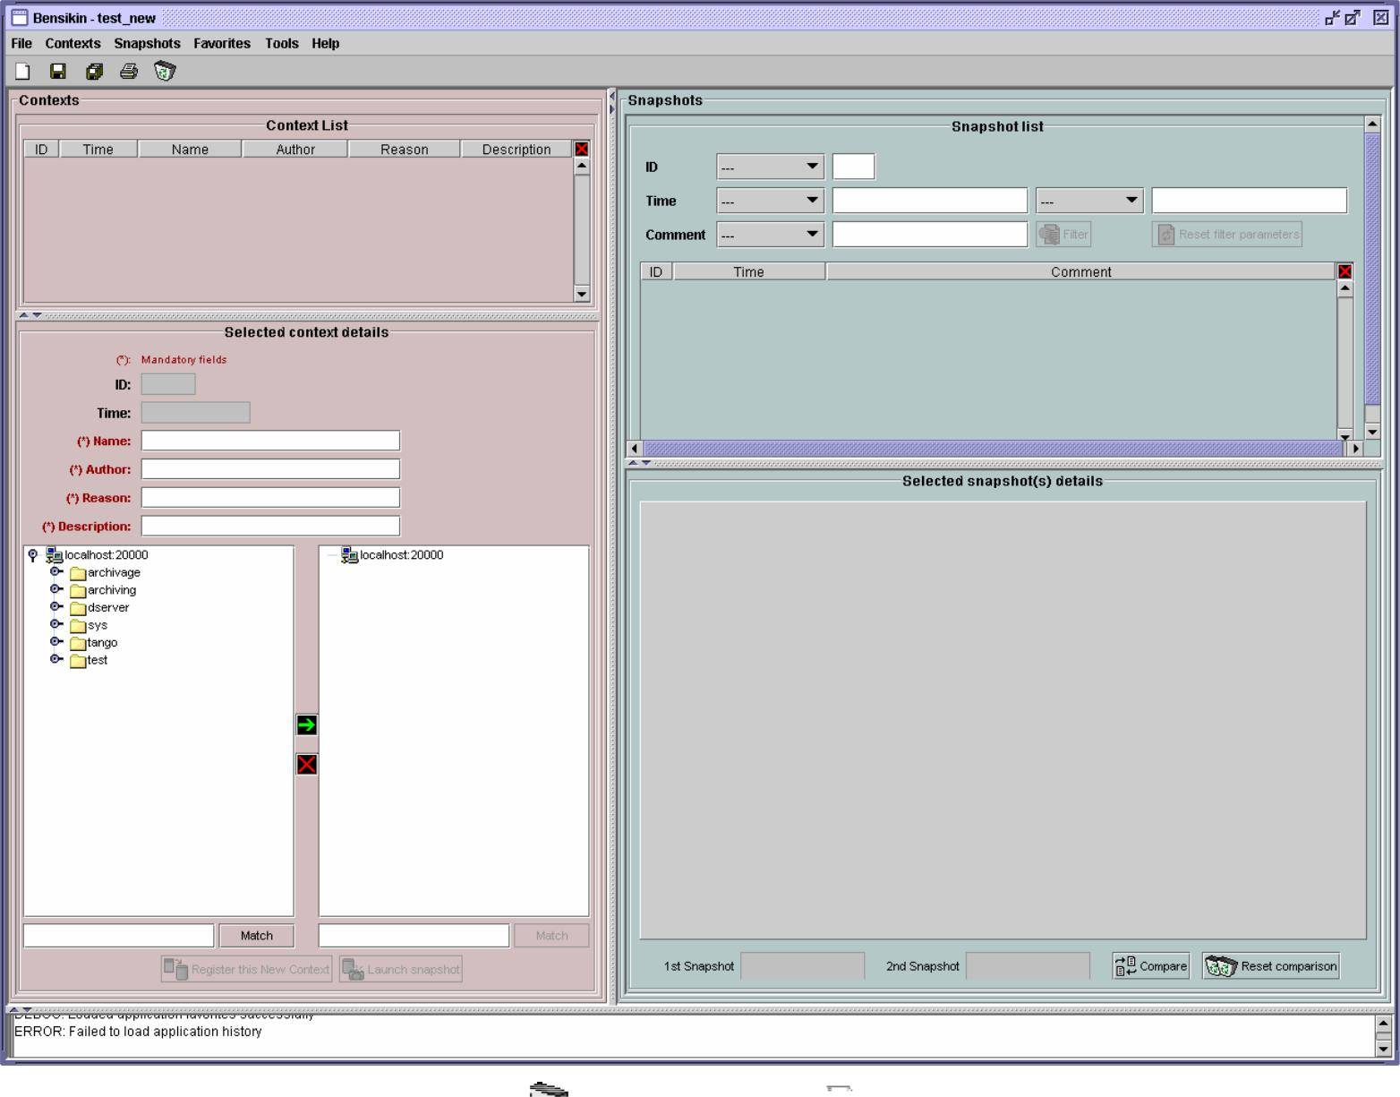

The difference between the “reset” icon() and the “new” icon( ) is, that the “reset” icon will clear every panel, whereas the “new” icon will only clear the snapshot list and the Context Details sub panel.

“Reference” Last Update : 8 February 2007 Page 9/26
Synchrotron Soleil Bensikin Manuel

5.1.1. Classic way (tree)

The tree on the left side of the Context Details sub panel allows you to check for available attributes. The one on the right side represents your context attributes.

To add attributes in your context browse the left tree, select attributes (represented by the icon ), and click on the arrow () to transfer them to the right tree.

To remove attribues from your context, select them in the right tree and click on the cross ().

Finally, fill the context meta data (Name, Author, Reason and Description) in the corresponding fields (Note

that filling the fields activates the “register” button).

Then, you can save your context in database by clicking on the “register” button .

Doing so will deactivate the “register” button and activate the “launch snapshot” button .

You can save your context in a file using the “save”icon .

“Reference” Last Update : 8 February 2007 Page 10/26
Synchrotron Soleil Bensikin Manuel

5.1.2. Alternate way (table)

To select this alternate way, go to “tools” menu and select “options”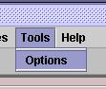.

Then select the “context” tab and click on the “table” radio button.

Figure 9: Options - Context Tab
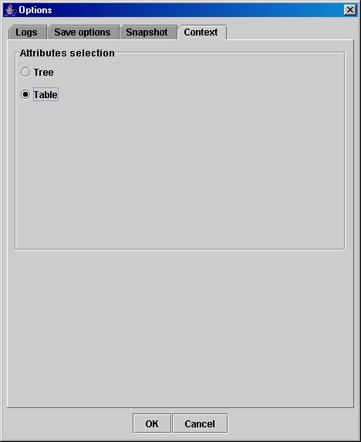

Click on the “ok” button. The context panel now has the “table selection mode”.

“Reference” Last Update : 8 February 2007 Page 11/26
Synchrotron Soleil Bensikin Manuel

Figure 10: Bensikin with Context Table Selection Mode (new Context)
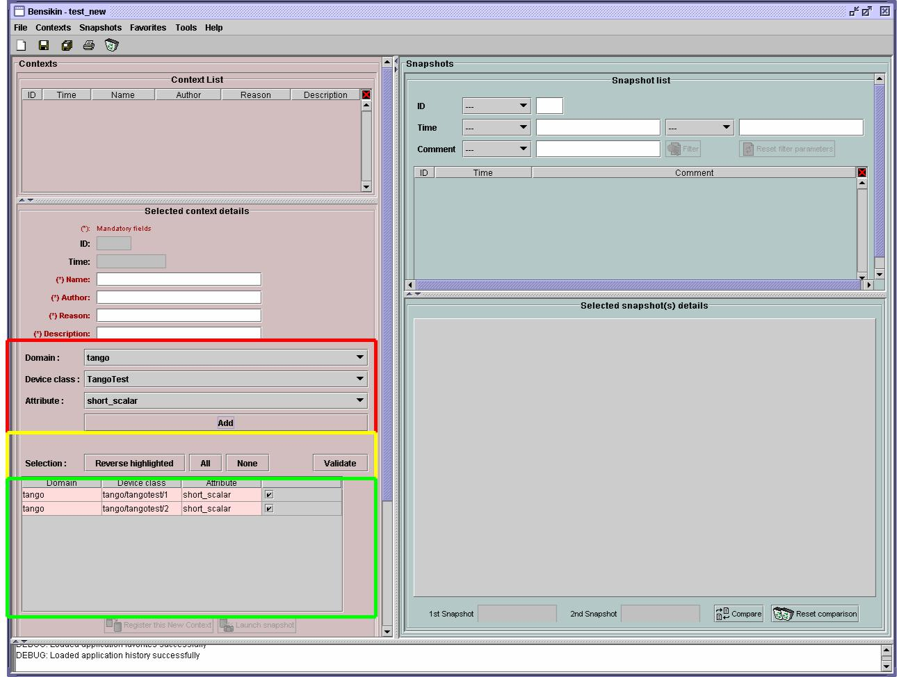

Attributes filtering box

Line-level selection buttons

List of Context attributes

(new attributes are light red)

- Attribute selection and automatic attributes adding:

- Choose a Domain. This refreshes the list of possible Device classes for this Domain.
- Choose a Device class. This refreshes the list of possible Attributes for this Domain and Device
class.
- Choose an Attribute and press OK : o All Attributes

  - with the selected name
AND
  - belonging to any Device of the selected Class and Domain are added to the current Context’s list of attributes.

All new attributes are light red until the Context is registered.

- Line level sub-selection of loaded attributes:

Each attributes is initially checked, but this check can be removed by the user. When the user clicks on “validate”, all unchecked attributes will be removed from the current Context.

- Click “All” to select all lines o Click “None” to select no lines

o Highlight lines in the list (CTRL and SHIFT are usable), then click “Reverse highlighted” to reverse the checked/unchecked status of all highlighted lines.

As for the classic way, you will have to fill the meta data fields and register your context in database by clicking on

the “register” button .

“Reference” Last Update : 8 February 2007 Page 12/26
Synchrotron Soleil Bensikin Manuel

5.2. Modifying an existing context

As a matter of fact, you can not really “modify” a context. What you can do is to create a new context with its informations (attributes and meta data) based on another one.

The very difference is in alternate mode, where former attribute are in white and new ones in light red :

Figure 11: Bensikin with Context Table Selection Mode (modified Context)
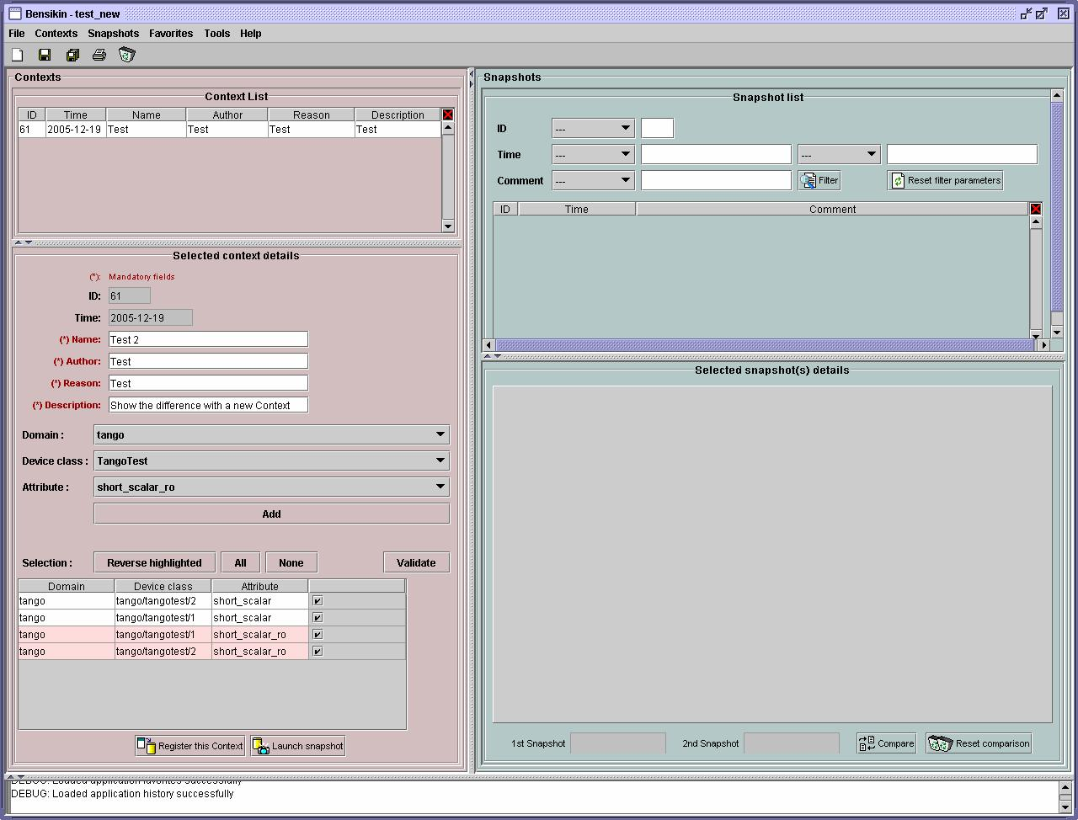

The “register” button changed a little too : its text is “Register this context” instead of “Register this new context”, as you can see on the figure above.

“Reference” Last Update : 8 February 2007 Page 13/26
Synchrotron Soleil Bensikin Manuel

5.3. Loading a context

There are 2 ways to load a context :

- Load it from the database

- Load it from a file

In both cases, loading a context will apply a quick filter on the snapshot list, so you can see the snapshots about this context that have been created this day (the day when you load the context).

5.3.1. Loading a context from database

In the “Contexts” menu, choose “load” then select “DB”:
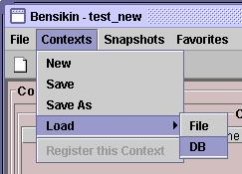

A dialog will then appear to allow you to filter the list of contexts in database following different criteria :

Figure 12: Database Context Filter Dialog
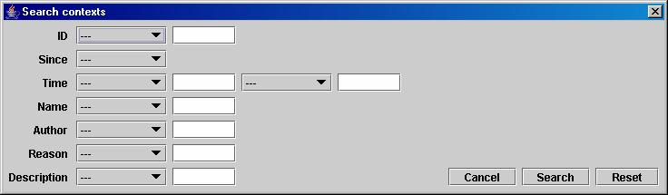

Select no criterion to search for all contexts present in database. Click on the button to apply the filter. The list of corresponding contexts will then appear in the Context List sub panel, as shown in Figure 7: Context Control Panel. Double click on a context in table to load it and see its details in the Context Details sub panel (See Figure 7: Context Control Panel).

If there are too many contexts in the list, you can remove some contexts from list (not from database) by selecting them in list and clicking on the cross on the top right corner of the list ().

5.3.2. Loading a context from file

In the “Contexts” menu, choose “load” then select “File”, or in “File” menu choose “load” then select “Context”:
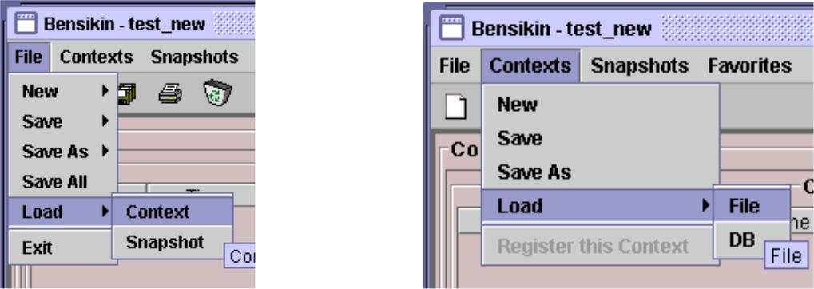

A classic file browser will appear. Search for your “.ctx” file and select it to load the corresponding context in the Context Details sub panel (See Figure 7: Context Control Panel).

“Reference” Last Update : 8 February 2007 Page 14/26
Synchrotron Soleil Bensikin Manuel

5.4. Printing a context

Once you have context ready, click on the “print” icon ( ) and select “context”:
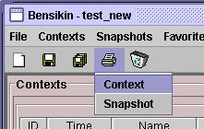

The classic print dialog will then appear. Validate your print configuration to print an xml representation of your context.

5.5. Saving a context

Once you have context ready, click on the “save” icon ( ) and select “context”:
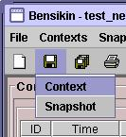

You also can go to menu “Contexts” and click on “save”, or go to menu “File”, select “Save” and click on “Context”.
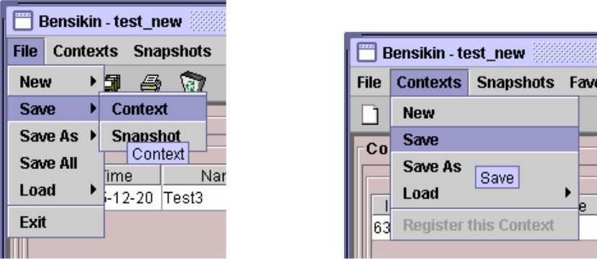

Then, the behaviour is “Word-like”. This means that if this is the first time you save this context, you will see the classic file browser to choose where to save your context, whith which file name. However, if not, it will automaticly save in the corresponding file. If you want to save in another file, you have to go to “File” menu, select “Save As” and click on “Context” , or go to “Contexts” menu and click on “Save As”
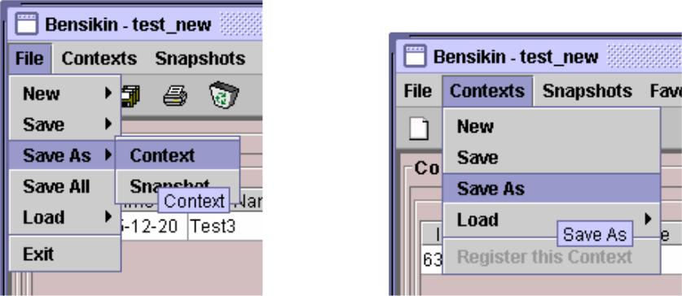

“Reference” Last Update : 8 February 2007 Page 15/26
Synchrotron Soleil Bensikin Manuel

6. Snapshot Management

This section describes how to control snapshots with Bensikin. A Snapshot is a view of your equipment at a precise date, view based on a context. A Snapshot has an ID, a creation date (Time), and a comment to describe it (which can be left empty).

Snapshots are managed in the snapshot control panel :

Figure 13: Snapshot Control Panel
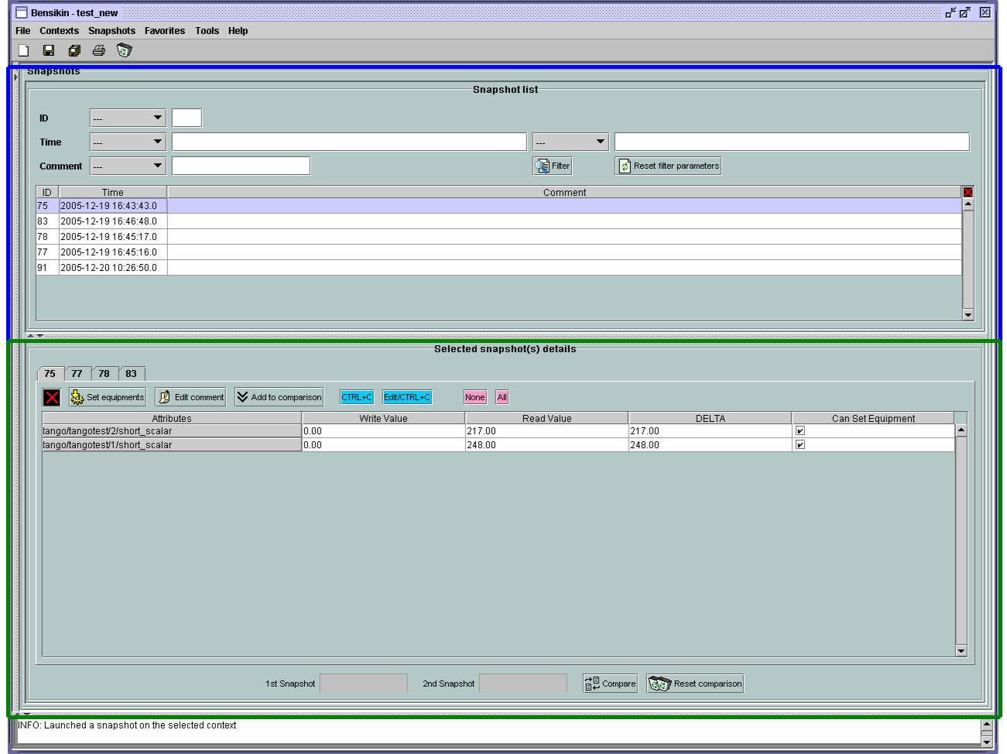

Snaphot List sub panel

Snapshot Details sub panel

“Reference” Last Update : 8 February 2007 Page 16/26
Synchrotron Soleil Bensikin Manuel

6.1. Creating a new snapshot

To create a new snapshot, first select a valid context in the context control panel (see Figure 7: Context Control

Panel). Then click on the button . The corresponding snapshot is added in the list of snapshots in the Snaphot List sub panel.

6.2. Loading a snapshot

There are 2 ways to load a snapshot :

- Load it from the database

- Load it from a file

6.2.1. Loading a snapshot from database

Loading a snapshot from database consists in adding this snapshot in the list of snapshots in the Snaphot List sub panel.

As you can see in Figure 13: Snapshot Control Panel, the Snaphot List sub panel allows you to filter snapshots from database to find the snapshot you want to load. However, have in mind that this filter is “context dependant”, which means that the snapshot that will appear in the list by clicking on the “filter”

button () are the one that correspond to your filter criteria AND the selected context in the Context
Control Panel. If the filter is cleared (which you can obtain by clicking on the button ), you will search for all the snapshots in database that correspond to the selected context.

6.2.2. Loading a snapshot from file

In the “Snapshots” menu, choose “load” then select “File”, or in “File” menu choose “load” then select “Snapshot”:
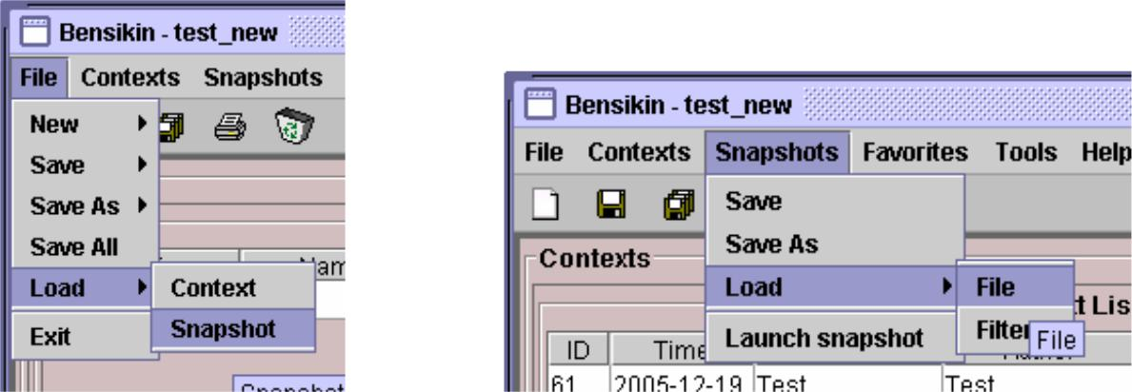

A classic file browser will appear. Search for your “.snap” file and select it to load the corresponding snapshot in the Snapshot Details sub panel (See Figure 13: Snapshot Control Panel).

“Reference” Last Update : 8 February 2007 Page 17/26
Synchrotron Soleil Bensikin Manuel

6.3. Editing a snapshot

To edit a snapshot, double click on the snapshot you want to edit in the snapshot list (in the Snaphot List sub panel). This will open a new tab about this snapshot in the Snapshot Details sub panel, tab named by this snapshot ID. If you load a snapshot from file, the name of the tab is the name of the file. To differenciate snapshots loaded
from file and the ones loaded from database, the snapshot loaded from file tabs have the icon .

6.3.1. Setting equipments with a snapshot

A snapshot allows you to set equipments with its attributes write values. You can choose which attributes will set equipments, and which not, by selecting or unselecting the corresponding check box in the column “Can Set Equipment” (See Figure 13: Snapshot Control Panel). By default, every attribute is selected. If you unselect some attributes, an icon will appear in tab title to notify you that these attributes will not set
equipments. You can quick select/unselect all the attributes by clicking on and buttons.When you
are ready to set equipments with the selected write values, click on the button .

You also can modify the write value before setting equipments by editing it in the table. If you do so, the value becomes red and a icon appears to warn you about the fact that you made modifications in this snapshot (these modifications will not be saved in database, they are just here to set equipments).

Figure 14: Modified snapshot
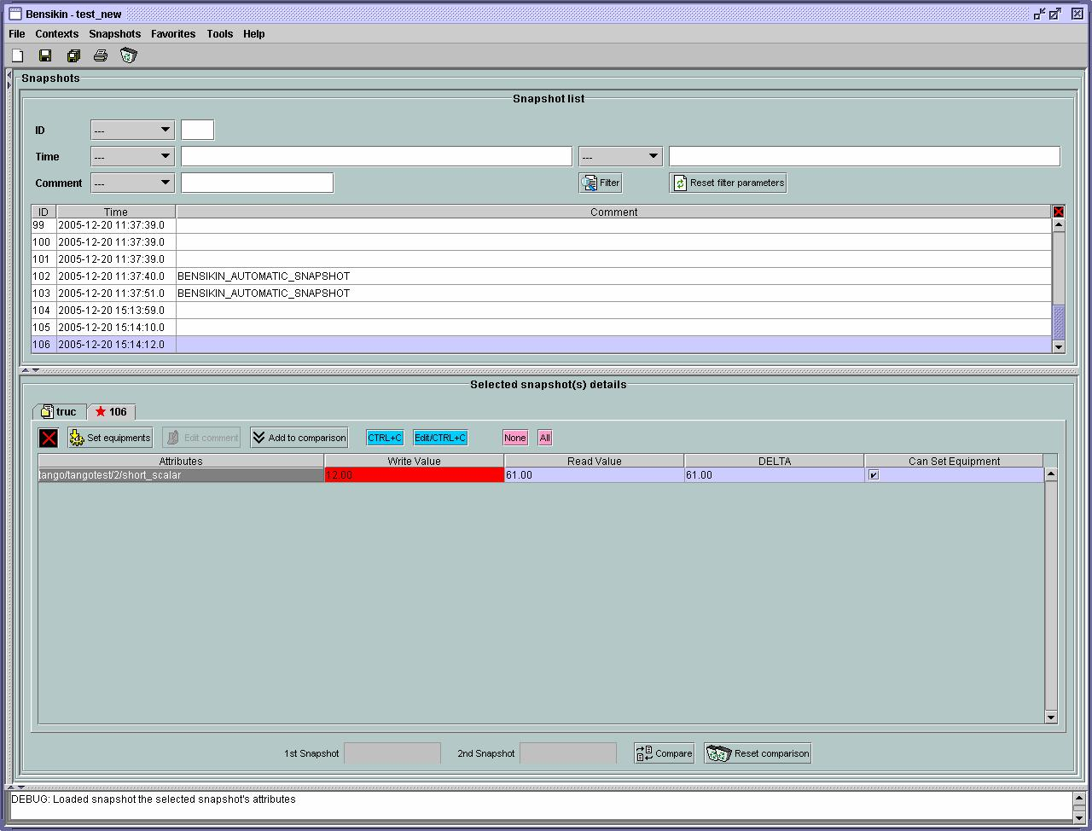

“Reference” Last Update : 8 February 2007 Page 18/26
Synchrotron Soleil Bensikin Manuel

6.3.2. Snapshot comparison

There are 2 ways to compare snapshots:

- Compare a snapshot with another one:

To do so, select a tab in Snapshot Details sub panel (See Figure 13: Snapshot Control Panel). Click on
button . You will see the tab title of this attribute appear in the field “1st snapshot”. Select
another tab and click again on button to put this attribute tab title in the field “2nd

snapshot”. Click then on button to see the comparison between these 2 snapshots.

Figure 15: Snapshot Comparison - full table
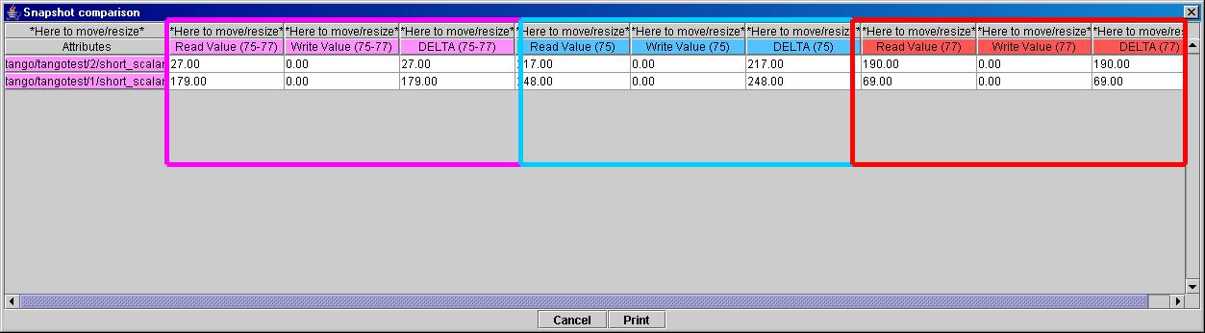

Difference Block 1st Snapshot Block 2nd Snapshot Block

You can print this comparison table by clicking on “Print “ button.

- Compare a snapshot with current state:

To compare a snapshot with current state, set this snapshot as “1st snapshot”, as explained above, and leave the “2nd snapshot” empty. Note that once the 1st snapshot is selected, you only can update the 2nd
snapshot or clear the comparison selection. To do so, click on the button . What is hidden behind this is a creation of a snapshot, named “BENSIKIN_AUTOMATIC_SNAPSHOT”, and you compare this snapshot with your snapshot. Have in mind that this automatic snapshot is registered in database. So, in the comparison table, the current state will appear as the second snapshot with the name “Current state” (red block in the comparison table).

6.3.3. Snapshot Details copy

As you can see in Figure 13: Snapshot Control Panel, snapshots are detailed in a table. You can copy this
table to clipboard as a text-CSV formated table by clicking on button. If you want to see this text result
and maybe filter it (like removing lines), click on button. You wiil see the text appear in a dialog.

Figure 16: Snapshot Edit Clipboard Dialog
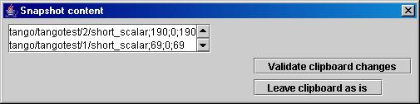

Modify the text as you want and click on “Validate clipboard changes” to copy it to clipboard and close the dialog.

You can modify the column separator in options.

6.3.4. Modifying a snapshot comment

Once your snapshot details are loaded, click on button to modify its comment (and save it in database or file).

“Reference” Last Update : 8 February 2007 Page 19/26
Synchrotron Soleil Bensikin Manuel

6.4. Printing a snapshot

Once you have context ready, click on the “print” icon ( ) and select “snapshot”:
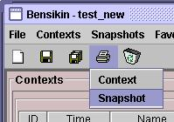

The classic print dialog will then appear. Validate your print configuration to print an xml representation of your snapshot.

6.5. Saving a snapshot

Once you have context ready, click on the “save” icon ( ) and select “snapshot”:
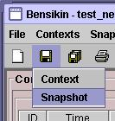

You also can go to menu “Sontexts” and click on “Save”, or go to menu “File”, select “Save” and click on “Snapshot”.
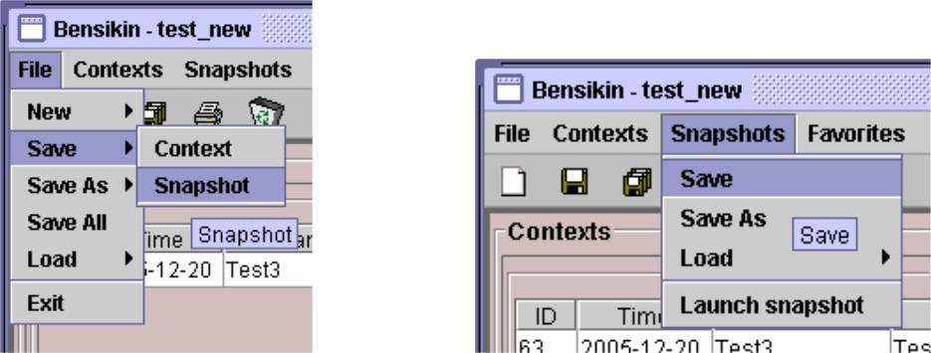

Then, the behaviour is “Word-like”. This means that if this is the first time you save this snapshot, you will see the classic file browser to choose where to save your snapshot, whith which file name. However, if not, it will automaticly save in the corresponding file. If you want to save in another file, you have to go to “File” menu, select “Save As” and click on “Snapshot”, or go to “Snapshots” menu and click on “Save As”
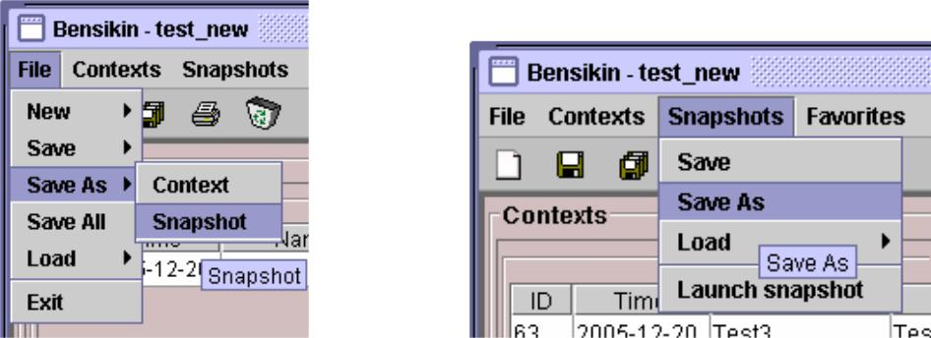

“Reference” Last Update : 8 February 2007 Page 20/26
Synchrotron Soleil Bensikin Manuel

7. Favorites

Bensikin manages a list of favorites context, so you can quickly switch to anyone of them. Those favorites are saved on application shutdown and loaded on startup.

7.1. Adding a context to favorites

To add a context to your favorites, have your context ready by creating or loading it. Then go to “Favorites” menu and click on “Add selected context”.
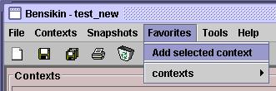

7.2. Switching to a context in favorites

To switch to a context in favorites, which means to load it from favorites, Go to Favorites” menu, select “contexts”, and click on the context you want to load.
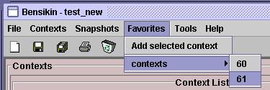

“Reference” Last Update : 8 February 2007 Page 21/26
Synchrotron Soleil Bensikin Manuel

8. Options

Bensikin manages global options. Those options are saved on application shutdown, and loaded on startup.

The Options menu is located in the Menu bar : ToolsÆOptions.

8.1. Logs Options

Choose the application’s log level.

Verbosity ranges from DEBUG (highest) to CRITIC (lowest), at least WARNING is recommended.

“Reference” Last Update : 8 February 2007 Page 22/26
Synchrotron Soleil Bensikin Manuel

Figure 17: Logs Options
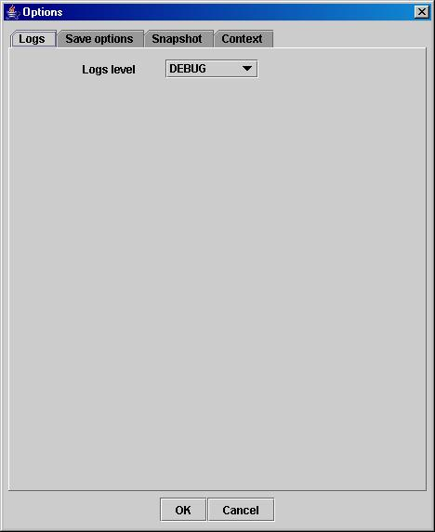

8.2. Application’s history save/load Options

Define whether Bensikin has a history, ie. a persistent state when closed/reopened.

If Yes is checked, a XML History file will be saved in Bensikin’s workspace, and on next startup the current Context and Snapshot will be loaded.

“Reference” Last Update : 8 February 2007 Page 23/26
Synchrotron Soleil Bensikin Manuel

Figure 18: Save Options
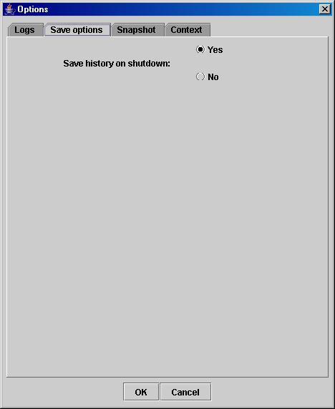

8.3. Snapshot Options

These are the Bensikin Snapshot Options:

“Reference” Last Update : 8 February 2007 Page 24/26
Synchrotron Soleil Bensikin Manuel

Figure 19: Snapshot Options
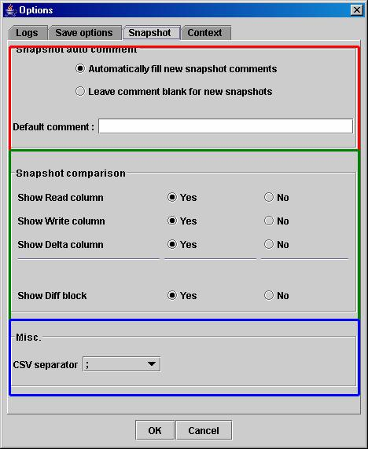

Comment Panel

Comparison Panel

Misc Panel

- In the Comment Panel, you can choose to automaticly set or not a value to a new snapshot comment. This

means, when you click on button, the newly created snapshot will or will not have a pre defined comment.

- In the Comparison Panel, you can choose wich columns you want to show/hide for every block in the Snapshot Comparison table. You can choose to show/hide the Difference block too (See Figure 15: Snapshot Comparison - full table)

- In the Misc Panel, you can choose the column separator for your text-CSV formated tables (See Figure 16: Snapshot Edit Clipboard Dialog)

“Reference” Last Update : 8 February 2007 Page 25/26
Synchrotron Soleil Bensikin Manuel

8.4. Context Options

Context options allow you to select which way you want to edit your contexts, see Figure 9: Options - Context Tab and the “5.1Creating a new context” section.

9. The Bensikin toolbar

The toolbar is located under the menu bar, and consists mainly of a set of shortcuts to often used functionalities.
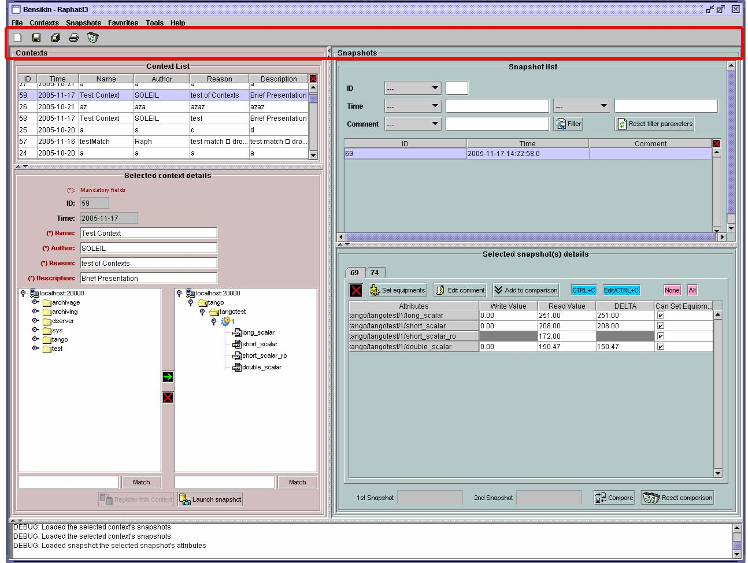

The toolbar

Figure 20: The Bensikin toolbar

- is a shortcut to creating a new Context

- is a shortcut to saving the selected Context/Snapshot into a Context/Snapshot file

- is a shortcut to doing a saving all opened Contexts and Snapshots

- is a shortcut to printing the xml representation of the current Context/Snapshot

- is a shortcut to removing all opened Contexts and Snapshots from display

“Reference” Last Update : 8 February 2007 Page 26/26

